***Project Abstract***

SocialScene is a social ­networking service that will provide a platform for users to rate and comment on tv shows, individual episodes, and movies, and sharing these ratings and comments to other users allowing for the coordination of content viewing amongst friends. Our platform will leverage the TMDb (the “Providers”) API in order to aggregate viewing options for our members.

***Customer***

Our target user (customer) consists of people who watch media through streaming sites such as Netflix and/or Amazon Prime Video, and have friends who do the same.

***Competitive Analysis***

The main features of our platform are as follows:

1) A social network allowing individual users to become friends and share information (potentially using Facebook’s Graph API, if feasible)

2) A content catalog from the Provider platforms, using publicly available APIs, with links directing the user directly to the content page on the Provider’s platform for viewing

3) A real­time comment and rating system, as well as private messaging (if there’s time)

4) Content suggestions specific to each user, sorted/organized using proprietary algorithms

With regards to IMDB, our biggest competitor and our inspiration for our app, IMDB allows you to rate movies and tv shows as well as rate and leave comments for other users of the website to view, which is similar to what we plan to accomplish with SocialScene. What makes SocialScene different (but more so an extension) from IMDB and other similar rating applications is our implementation of sharing rated movie and television content with a user’s social group via Facebook sharing by API.

***User Stories***

**Current Iteration:**

//Want user to be able to login to static landing page

//Want to connect database table backend with React GUI frontend to achieve this

//Want to record and log emails and passwords of each user after login

Upon arriving to the SocialScene website, the user is prompted to click the login button if an existing user, or the register button if a new user.

If selecting the login button, the user is prompted to enter their login email and password.

If selecting the register button, the user is prompted to enter their first name, last name, login email and login password.

The user logs into SocialScene and is directed to a landing page greeting the user to our website.

//The website’s database records the user’s login information (email & password) into a table consisting of all the users of SocialScene. If a new user to SocialScene registers, the database table is updated with the user’s first and last name as well as their email and password together.

**Index:**

* The **actor** for each user story is the user (customer), we only have 1 actor with regards to our application
* **MAKE SURE TO CHANGE (REMOVE THE BLURB) LATER:** 
  + - **GREEN: THINGS THAT CAN MAYBE BE FINISHED THIS ITERATION**
    - **RED: THINGS TO DELETE AS WE’VE CHANGED THE PLAN/SCRAPPED THE IDEA**
    - **BLUE: THE GOOD STUFF (THAT’S ALREADY DONE MINUS TEST CASES)**
* **Our App is powered by the TMDb API database which allows us to get information for the user features we have worked on in our application**

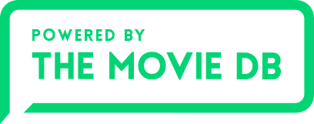

**1. User story: Ability to Register a User Session**

* Description:
  + Users can register by entering their first name, last name, email and password
* Precondition:
  + The user must have not signed up for the application
* Post-condition:
  + The user will be able to view the SocialScene dashboard (landing) page
* Action:
  + User clicks the Register button and fills out corresponding information
* Acceptance Criteria:
  + User fills out all the information required (first name, last name, email and password)
  + User has not already been registered with the same e-mail (as the email is the primary key used to identify a user)
* Test Cases:
  + When the incorrect/no password is entered there will be an “invalid credentials” error message
  + When passwords do not match, there will be a “invalid password” error message
  + When no email is entered there will be an “invalid credentials” error message

**2. User story: Ability to login/logout.**

* Description:
  + Users can login by entering their email and password, logout after clicking the button after arriving at the landing page
* Precondition:
  + The user must have already signed up for the application
* Post-condition:
  + The user will be able to view the SocialScene dashboard page
* Action:
  + User clicks the Login button and fills out corresponding information
  + User clicks the Logout button and is logged out and redirected back to the title page
* Acceptance Criteria:
  + User fills out all the information required (email and password)
* Test Cases:
  + When the incorrect/no password is entered there will be an “invalid credentials” error message
  + When passwords do not match, there will be a “invalid password” error message
  + When no username is entered there will be an “invalid credentials” error message

(Good idea for a Test Case: The user must have at least 1 uppercase letter, 1 number and a minimum of 5 characters in their password)

**3. User Story: Ability to Search for a Title (TV show/movie) (search)**

* actor: user
* precondition: user has signed in
* trigger (automated precondition): as soon as one letter is typed, the main screen is replaced by the search screen, user sees title if exists, is replaced by title screen onclick
* action: user clicks on search field and types in title of content they’re looking for
* acceptance criteria: user finds the title
* testing: is able to type in search bar, screen switch to search screen as soon as first

latter is typed, able to click on desired title

**3. User Story: Ability to Search for a (Movie/TV) Title**

* Description:
  + Users can search for a movie title by typing a keyword of the title in the search box, able to switch between results by changing pages after query is issued and loaded
* Precondition:
  + The user must have already signed up for the application (be logged in)
* Post-condition:
  + The user will be able to view the SocialScene dashboard page
  + When the incorrect/no password is entered there will be an “invalid credentials” error message
  + When passwords do not match, there will be a “invalid password” error message
  + When no email is entered there will be an “invalid credentials” error message
* Action:
  + User clicks on search field and types in a keyword query into the search bar
* Acceptance criteria:
  + User finds titles containing the keyword query the user had searched for
* Test Cases:
  + The user will be able to view the SocialScene search bar on the dashboard page
  + When no keyword is given, there will be an “invalid credentials” error message
  + When at Page 1, unable to click the previous button to the non-existent “Page 0”
  + Able to type queries into the search bar

**4. User Story: Ability to View Landing Page after Login**

* Description:
  + Users can see the favourite movies of the user on the landing page
* Precondition:
  + The user must have already signed up for the application (be logged in)
* Post-condition:
  + The user will be able to view the SocialScene dashboard page
* Action (Trigger):
  + User registers or logs in and is redirected to the landing page
* Acceptance Criteria:
  + User logs in or registers to SocialScene
* Test Cases:
  + The user will be able to view the SocialScene dashboard (landing) page, with search bar for titles contained within it
  + When no keyword is given in the search bar, there will be an “invalid credentials” error message

**5. User Story: Ability to Edit Login of a User**

* Description:
  + Users can edit login by entering a new password, first name and last name using their original login email
* Precondition:
  + The user must already have an existing registration using their email on the SocialScene database
* Post-condition:
  + The user will be able to edit their password, first name, and last name as they wish
* Action:
  + User clicks the Edit Login button on the landing page and fills out corresponding information
* Acceptance Criteria:
  + User fills out all the new information they require to change (password, first name, last name)
* Test Cases:
  + When no password is entered there will be an “invalid credentials” error message
  + When no first name, last name is entered there will be an “invalid credentials” error message

**6. User Story: Ability to Rate a (Movie/TV) Title**

* Description:
  + Users can rate a (Movie/TV) Titlewhen viewing the details of a specific title
* Precondition:
  + The user must be logged in and in the description page of a specific (Movie/TV) title
* Post-condition:
  + The user will be able to rate the specific (Movie/TV) title
* Action:
  + User clicks on the rating image to assign a star rating between 1-5 stars
* Acceptance Criteria:
  + User assigns a rating to the specific (Movie/TV) title
* Test Cases:

**7. User Story: Ability to View Details of a (Movie/TV) Title**

* Description:
  + Users can edit login by entering their email and password
* Precondition:
  + The user must have already signed up for the application
* Post-condition:
  + The user will be able to view the details of the title
* Action:
  + User searches for a (Movie/TV) title using a keyword query and then clicks on a specific title to see an overview description of the title
* Acceptance Criteria:
  + User searches and selects a specific (Movie/TV) title
* Test Cases:
  + When no keyword query is entered in the search bar, there will be an “invalid credentials” error message

**Upcoming Iterations:**

* Share button to share what a user is currently interested in to their social group via Facebook
* Write comments under reviewed media that other users are able to view
* Ability to hover over titles to see movie/tv details
* Ability to toggle dark mode on our site
* Ability to view favourite titles of your social group (friends)

***UI Mockup***

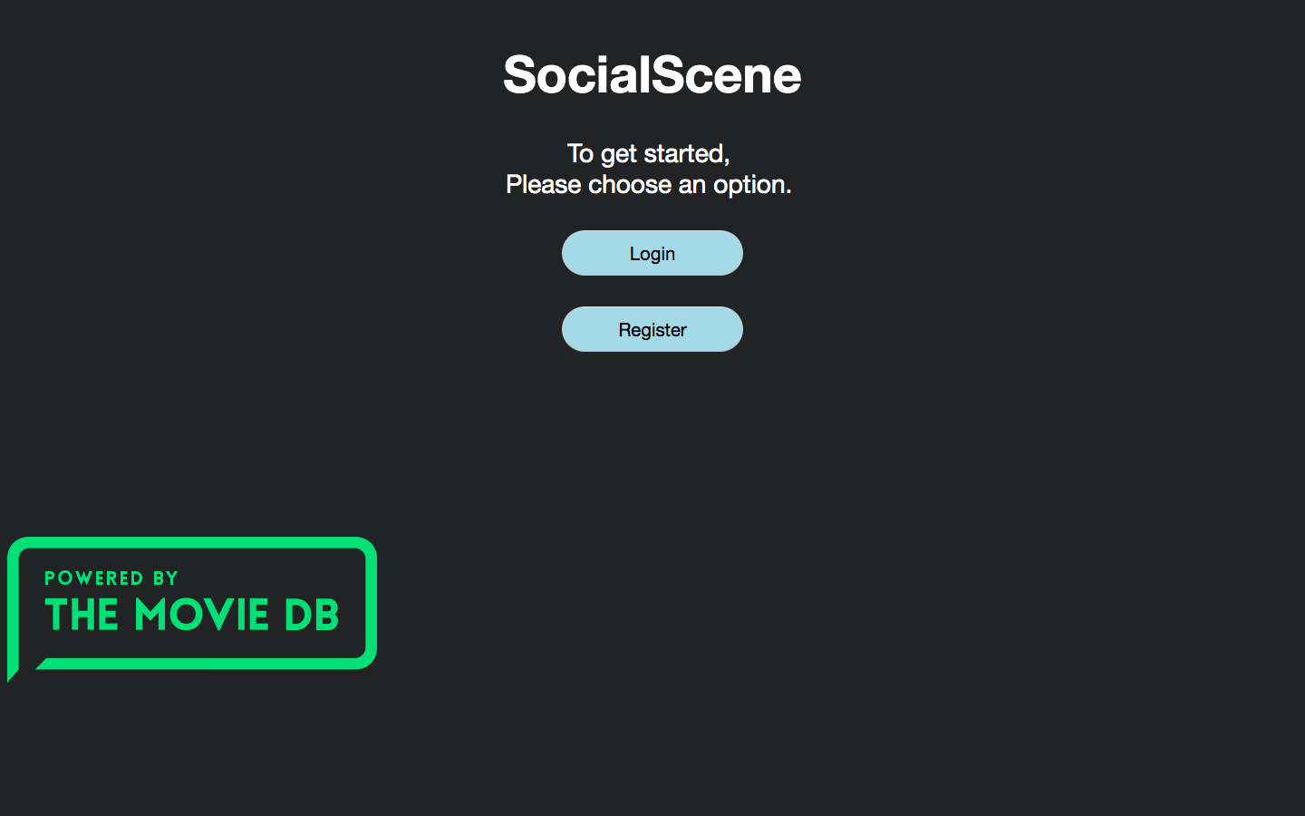

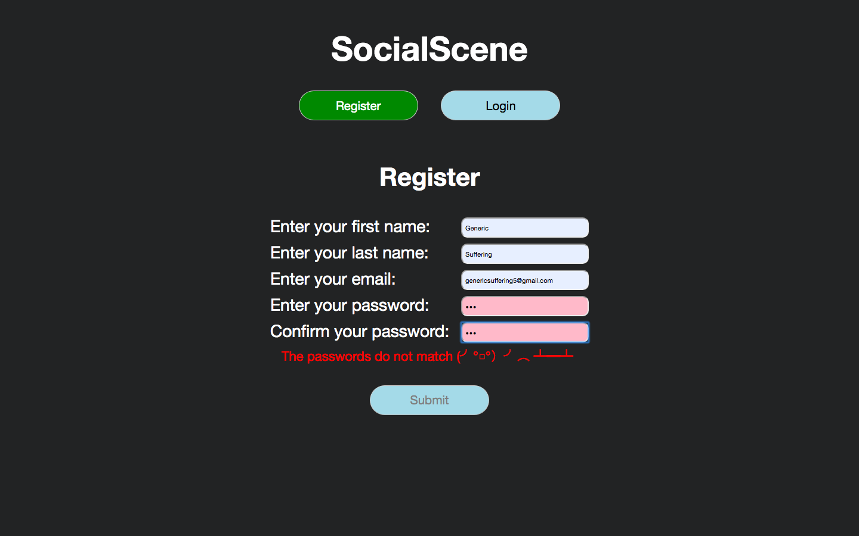

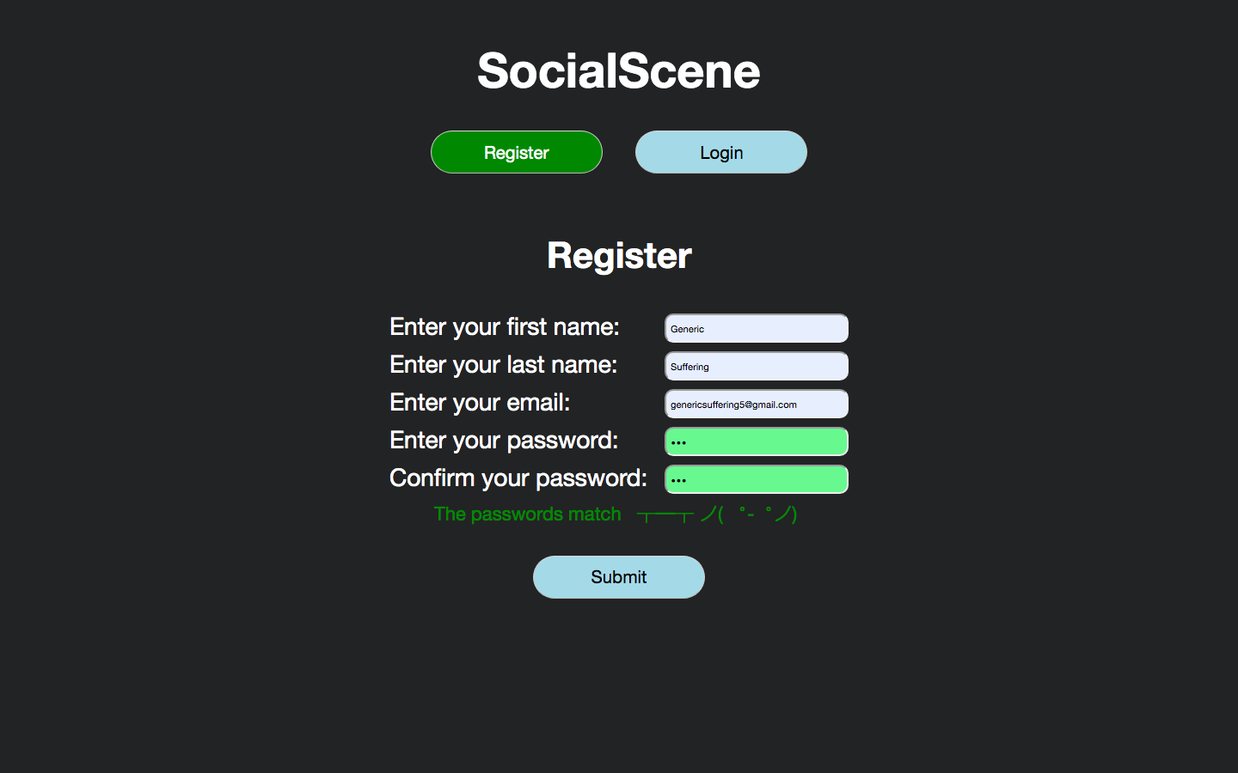

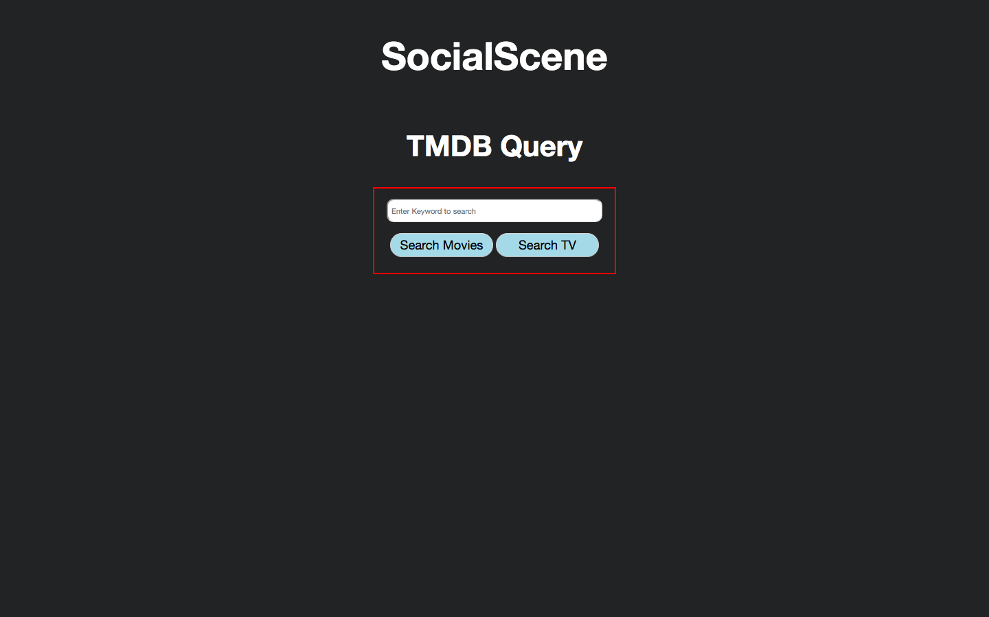

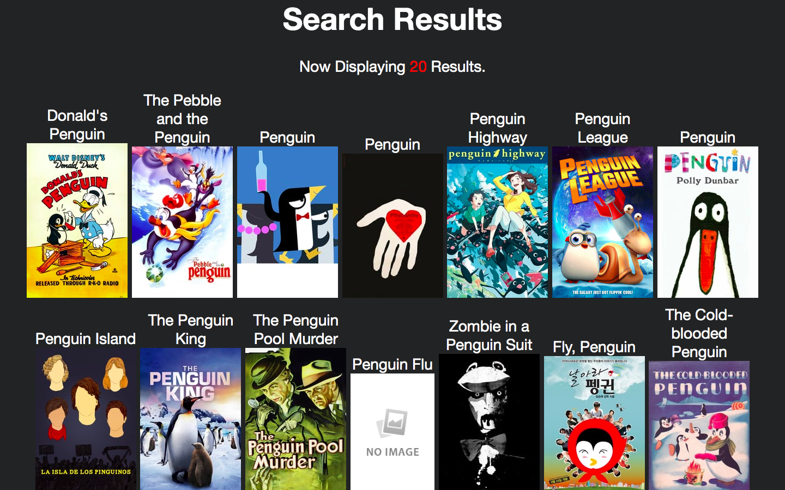

***Velocity Measurement***

The following are all of the stories implemented sorted by iteration with their corresponding points:

**Iteration 1:**

1. User Story: Ability for user to login/register (2 points)

Total points per group member for iteration 1:

* Abel: 2 points
* Simon: 1 point
* Johnson: 1 points
* Ibrahim: 1 points
* Sergii: 1 point

**Iteration 2:**

1. **User story: Ability to Login/ Logout (2 points)**
2. **User Story: Ability to Register a User Session**
3. **User Story: Ability to Search for a (Movie/TV) Title**
4. **User Story: Ability to View Landing Page after Login**
5. **User Story: Ability to Edit Login of a User**
6. **User Story: Ability to Rate a (Movie/TV) Title**
7. **User Story: Ability to View Details of a (Movie/TV) Title**

Total points per group member for iteration 2:

* Abel: 2 points
* Simon: 0 points
* Johnson: 2 points
* Ibrahim: 1 point
* Sergii: 1 point

Things to do for Requirement Document:

- Update UI Mockup after project is completed for iteration 2

- Update Velocity Measurement after Bobby replies to email

- Remove Red Writings after Bobby replies to email

- Update Test Cases after Testing is finished

- Formatting to make look nice

- Double Check each User Story after project is completed to make sure each User Story is properly updated to current progress

- Order User Stories? (Could help for Clarity)